SIMATS ENGINEERING (SAVEETHA SCHOOL OF ENGINEERING)
Department of Computer Science and Engineering
CO1 ASSESSMENT TOOL 2 – Agile Sprint Planning & User Story Workshop

Course Code: | CSA10 / CSA1063 | Course Title: | Software Engineering
CO Assessed: | CO1 | Assessment: | Assessment Tool 2 – Agile Sprint Planning & User Story Workshop
Weightage: | 20% | Total Marks: | 25
CO1 Statement: | Apply advanced methodologies and agile project management techniques to manage software projects effectively
Student Name: | Dhanush S | Reg. No.: | 192511180
Date: | 13-10-2026 | Duration: | 60 minutes

Code of Conduct
I Dhanush S / 192511180 certify that this submission is my original work and that I have adhered to the guidelines specified for this assessment. I understand that any violation of academic integrity rules will result in disciplinary action.
Signature of the Student: _________________________

Annexure A – Agile Sprint Planning & User Story Workshop
Instructions to Students:
Each student is assigned an individual software project problem statement. Based on the given problem statement, perform an Agile Sprint Planning and User Story Workshop by applying Agile software engineering practices. Prepare a comprehensive sprint planning document covering the following aspects:
Based on the given problem statement, perform an Agile Sprint Planning and User Story Workshop by applying Agile software engineering practices. Prepare a comprehensive sprint planning document covering the following aspects:
- Identify the Project Vision and Stakeholders
  - Define the project's vision, objectives, and identify all key stakeholders involved.
- Create Epics and User Stories
  - Break down the requirements into Epics and formulate well-structured User Stories using the format:
As a <user>, I want <feature>, so that <benefit>.
- Define Acceptance Criteria
  - Write clear and measurable acceptance criteria for each selected user story using the Given–When–Then format or equivalent.
- Prioritize the Product Backlog
  - Organize and prioritize the product backlog based on business value, customer needs, and project dependencies.
- Plan the Sprint Backlog
  - Select high-priority user stories for the first sprint and divide them into actionable development tasks.
- Estimate Effort Using Story Points
  - Assign story points to each selected user story using an appropriate estimation technique (e.g., Fibonacci sequence or Planning Poker) and justify your estimates.
- Present the Sprint Goal and Expected Deliverables
  - Define a clear sprint goal and describe the expected sprint deliverables, including the features to be completed at the end of the sprint.
Problem Statement: Smart Grocery Consumption and Reorder Management System
This workshop document continues the work of Assessment Tool 1. There, the Smart Grocery Consumption and Reorder Management System was analysed and Agile Scrum was selected as the development framework, with a plan of six two-week sprints. Here, the same project is broken into a vision, epics, user stories, a prioritised product backlog and a detailed plan for Sprint 1.
1. Identify the Project Vision and Stakeholders
1.1 Project Vision
Vision Statement
For households, hostel messes, canteens and small grocery stores who cannot easily tell what stock is left or when to buy again, the Smart Grocery Consumption and Reorder Management System is a web and mobile application that records purchases and consumption, predicts when each item will run out and recommends the right reorder at the right time. Unlike handwritten lists and shopping apps that only show past orders, our product joins inventory, consumption, prediction and ordering in one platform and always leaves the final approval to the user.

1.2 Project Objectives
The objectives below come from the problem statement. Each has a measure of success so that the Product Owner can judge progress at every sprint review. The target values are planning assumptions for the first year after release.
Objective | Measure of Success (target)
Keep an accurate digital inventory of groceries and consumables | At least 95% of recorded items match physical stock in a monthly spot check.
Reduce stock-outs of essential items | 40% fewer stock-outs compared with the household's own baseline.
Reduce food wastage and duplicate buying | 25% less discarded food, measured through discarded-quantity records.
Predict run-out dates accurately | Run-out date within ±2 days of the actual date for 80% of staple items after 8 weeks of data.
Save shopping and planning effort | Weekly shopping-list preparation reduced from about 30 minutes to under 5 minutes.
Keep the user in control and the data safe | Every order needs user approval unless auto-order is enabled; no critical security defects at release.

1.3 Key Stakeholders
Stakeholders are the people and organisations who use, build, fund or are affected by the product. The Product Owner speaks for the user-side stakeholders when the backlog is ordered.
Stakeholder | Role in the Project | Main Expectation
Product Owner (internal) | Owns the vision and the product backlog, sets priorities, writes acceptance criteria with the team and accepts or rejects finished stories. | Maximum business value from every sprint.
Scrum Master (internal) | Coaches the team in Scrum, runs the events, protects the sprint and removes impediments. | A smooth, self-organising team.
Development Team (internal) | Two backend developers, one frontend developer, one full-stack/DevOps developer and one QA engineer design, build, test and deploy the product. | Clear stories, realistic sprint commitments and stable requirements during a sprint.
Household Users / Customers | Primary users who register items, record purchases and usage, approve reorders and set budgets. | Fewer stock-outs, less wastage and effortless data entry.
Family Members / Shared Users | Update consumption and the shared list and respond to alerts. | A single shared view with no conflicting updates.
Store Managers / Canteen Staff | Monitor bulk stock and plan weekly purchases for many consumers. | Reliable low-stock signals and demand forecasts at volume.
Grocery Vendors / Suppliers | Provide catalogue, prices and availability; accept and fulfil orders through APIs. | Clean, well-documented API orders with few mismatches.
Delivery Partners | Deliver confirmed orders on the chosen date and slot. | Correct address and slot details.
Payment Service Providers | Process payments securely and confirm transaction status. | Compliant, secure and fraud-safe payment requests.
System Administrators | Manage accounts, monitor system health, take backups and apply security updates. | Monitoring, backup and security features from the start.
Data Science Team | Build and tune the prediction models used from Sprint 4. | Enough clean consumption data and early access to it.

1.4 Scrum Team and Working Agreements
- Team: 1 Product Owner, 1 Scrum Master and a 5-member Development Team (BE1, BE2, FE, FS, QA).
- Sprint length: 2 weeks (10 working days), with six planned sprints as in Assessment Tool 1.
- Events: Sprint Planning, Daily Scrum (15 minutes), Backlog Refinement, Sprint Review and Sprint Retrospective.
- Definition of Ready: a story enters a sprint only when it is estimated, has acceptance criteria and has no open dependency.
2. Create Epics and User Stories
2.1 Epics
The requirements are grouped into ten epics. They match the functional modules proposed in Assessment Tool 1, so the two documents stay consistent.
ID | Epic | Description | User Stories
E1 | User and Household Management | Registration, secure login, household creation, invitations and member roles. | US01–US04
E2 | Inventory Management | Add, view, search, edit and delete grocery items with unit, quantity and minimum stock level. | US05–US08
E3 | Purchase Capture | Record purchases by manual entry, barcode scan or receipt upload (OCR). | US09–US11
E4 | Consumption Tracking | Log daily usage with quick entries and review consumption history. | US12–US13
E5 | Expiry and Wastage Management | Track expiry dates, highlight use-first items and record discarded quantities. | US14–US15
E6 | Reorder Management | Build reorder suggestions from minimum stock rules and let users approve them. | US16–US17
E7 | Prediction Engine (AI/ML) | Forecast run-out dates with a confidence indicator and seasonal adjustment. | US18–US19
E8 | Vendor and Order Integration | Compare vendors, place and pay for orders, and track order status. | US20–US22
E9 | Alerts and Notifications | Low-stock and expiry alerts through push, SMS or email. | US23–US24
E10 | Reporting and Analytics | Spending and wastage dashboards and CSV/PDF export. | US25–US26

2.2 User Stories
Every story follows the format As a <user>, I want <feature>, so that <benefit>. The stories are written to be INVEST: independent where possible, negotiable, valuable, estimable, small enough for one sprint and testable.
ID | Epic | User Story
US01 | E1 | As a household user, I want to register and log in with my email or mobile number and a password, so that my household data stays private and secure.
US02 | E1 | As a logged-in user, I want to create a household (home, hostel mess, canteen or shop), so that all stock and purchases are kept together in one shared space.
US03 | E1 | As a household admin, I want to invite family members or staff using an invite code, so that everyone can update the same inventory.
US04 | E1 | As a household admin, I want to give each member an Admin, Member or View-only role, so that only trusted people can change stock or approve orders.
US05 | E2 | As a household member, I want to add an item with its category, unit, quantity and expiry date, so that I have one accurate list of what is available at home.
US06 | E2 | As a household member, I want to view, search and filter the inventory list, so that I can find any item and see what is running low in seconds.
US07 | E2 | As a household member, I want to edit or delete an item, so that wrong or old entries can be corrected quickly.
US08 | E2 | As a household member, I want to set a minimum stock level for each item, so that the system knows when an item is running low.
US09 | E3 | As a household member, I want to record a purchase with quantity, price and date, so that the stock increases automatically after shopping.
US10 | E3 | As a household member, I want to scan the barcode of a packaged product, so that I can add purchases without typing.
US11 | E3 | As a household member, I want to upload a shopping receipt, so that all items on the bill are added in one step.
US12 | E4 | As a household member, I want to log usage such as "used 1 kg rice", so that the stock reduces without opening many screens.
US13 | E4 | As a household member, I want to view the consumption history of an item, so that I understand how fast each item is being used.
US14 | E5 | As a household member, I want to see a list of items that will expire soon, so that I can use them first and avoid wastage.
US15 | E5 | As a household member, I want to record the quantity of an item I had to discard, so that wastage is measured and can be reduced.
US16 | E6 | As a household user, I want to see a shopping list with recommended quantities, so that I never forget an essential item.
US17 | E6 | As a household user, I want to edit, approve or reject each suggested order, so that I stay in control of what is bought.
US18 | E7 | As a household user, I want to see the date on which each item is expected to finish, so that I can plan my next purchase in advance.
US19 | E7 | As a household user, I want to see a confidence indicator and festival or season adjustment on each prediction, so that I know how much to trust the forecast.
US20 | E8 | As a household user, I want to compare vendors and place an approved order, so that I get the best price without visiting many shops.
US21 | E8 | As a household user, I want to pay for an order through a payment gateway, so that the order is completed in one flow.
US22 | E8 | As a household user, I want to track the status of my order, so that I know when the delivery will arrive.
US23 | E9 | As a household user, I want to receive an alert when an item falls below its minimum level, so that I can buy it before it runs out.
US24 | E9 | As a household user, I want to receive an alert before an item expires, so that I can use it in time.
US25 | E10 | As a household user, I want to see a dashboard of spending, consumption and wastage, so that I can stay within my monthly budget.
US26 | E10 | As a household user, I want to export reports as CSV or PDF, so that I can share or keep records.

TS01 is a technical enabler rather than a user story. It delivers no direct user value but sets up the repository, CI pipeline and database design that every story depends on, so it is kept in the backlog and estimated like a story.
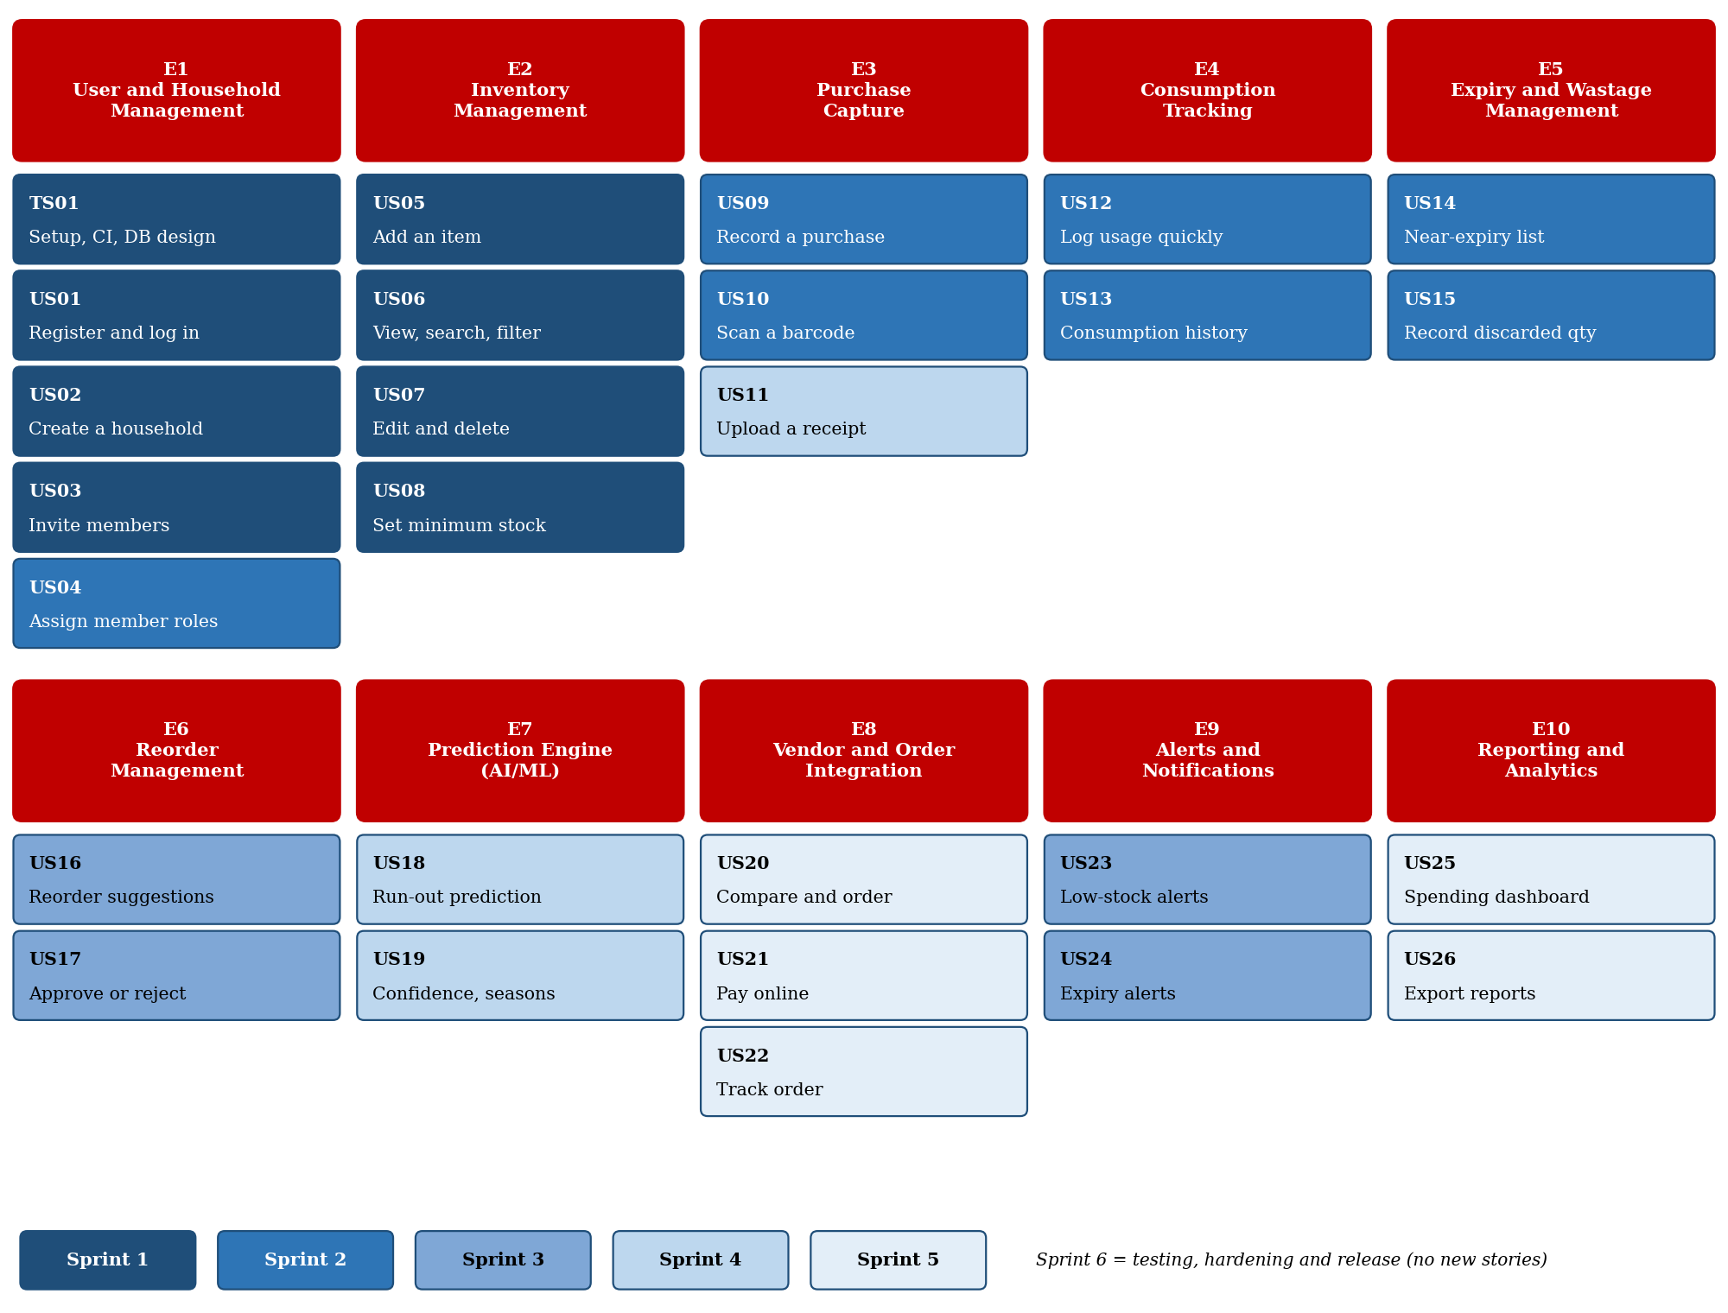
Figure 2.1: User story map – epics (red) with stories colour-coded by planned sprint
3. Define Acceptance Criteria
Acceptance criteria are written in Given–When–Then form for every story selected for Sprint 1. Each criterion is specific, measurable and testable, and the QA engineer turns each row into a test case. Criteria for the later stories are written during backlog refinement before those stories enter a sprint.
TS01 – Technical enabler: project set-up, CI pipeline and database design
# | Given | When | Then
1 | Given a developer pushes code to the repository | When the CI pipeline runs | Then the build and unit tests run automatically and the result is reported within 10 minutes
2 | Given an empty database | When the migration command is run | Then all tables are created in one step and at least 10 categories and the standard units are loaded
3 | Given the API is running | When a developer opens the API documentation page | Then every Sprint 1 endpoint is listed with request and response formats

US01 – Register and log in
As a household user, I want to register and log in with my email or mobile number and a password, so that my household data stays private and secure.
# | Given | When | Then
1 | Given I am a new user on the registration page | When I submit a valid name, e-mail or mobile number and a password of at least 8 characters with a letter and a digit | Then my account is created, the password is stored only as a hash and I am taken to the login page within 3 seconds
2 | Given an e-mail or mobile number is already registered | When I try to register with it again | Then the system shows "Account already exists" and no duplicate account is created
3 | Given I am a registered user | When I log in with correct credentials | Then I reach the home screen and the session expires after 30 minutes of inactivity
4 | Given I am a registered user | When I enter a wrong password 5 times in a row | Then the account is locked for 15 minutes and a lock message is shown

US02 – Create a household
As a logged-in user, I want to create a household (home, hostel mess, canteen or shop), so that all stock and purchases are kept together in one shared space.
# | Given | When | Then
1 | Given I am logged in and have no household | When I enter a household name of 3–50 characters, choose a type (Home, Hostel Mess, Canteen, Shop) and submit | Then the household is created and I become its Admin
2 | Given I am on the create-household screen | When I submit with an empty or too-short name | Then a field error is shown and no household is created
3 | Given I have created a household | When I open the home screen | Then the household name and a member count of 1 are displayed

US03 – Invite household members
As a household admin, I want to invite family members or staff using an invite code, so that everyone can update the same inventory.
# | Given | When | Then
1 | Given I am a household Admin | When I choose Invite Member and enter an e-mail or mobile number | Then a unique 6-digit invite code valid for 48 hours is generated
2 | Given I am a registered user with a valid, unused code | When I enter the code on the join screen | Then I am added to the household as a Member and the Admin's member list shows me
3 | Given a code is expired or already used | When I enter it | Then "Invite code invalid or expired" is shown and I am not added

US05 – Add an inventory item
As a household member, I want to add an item with its category, unit, quantity and expiry date, so that I have one accurate list of what is available at home.
# | Given | When | Then
1 | Given I am on the Add Item screen | When I enter name, category, unit (kg, litre, packet, piece) and a quantity greater than 0 and submit | Then the item is saved and appears in the inventory list immediately
2 | Given I leave name, category, unit or quantity empty, or enter a quantity of 0 or less | When I submit | Then field-level errors are shown and nothing is saved
3 | Given I enter an expiry date earlier than today | When I submit | Then the date is rejected with an error message
4 | Given an item with the same name, category and unit already exists | When I add it again | Then the system asks whether to update the existing quantity instead of creating a duplicate

US06 – View, search and filter inventory
As a household member, I want to view, search and filter the inventory list, so that I can find any item and see what is running low in seconds.
# | Given | When | Then
1 | Given my household has 500 items | When I open the Inventory screen | Then the first 20 items load in 3 seconds or less
2 | Given the inventory list is open | When I type part of an item name in the search box | Then only matching items are shown (not case-sensitive) within 1 second
3 | Given the inventory list is open | When I filter by category or by Low Stock | Then only matching items are listed together with the count of results

US07 – Edit and delete an item
As a household member, I want to edit or delete an item, so that wrong or old entries can be corrected quickly.
# | Given | When | Then
1 | Given an item exists | When I change its quantity, unit or expiry date and save | Then the new values show in the list and the change time and user are recorded
2 | Given an item exists | When I choose Delete and confirm | Then the item no longer appears in the inventory list (soft delete)
3 | Given an item exists | When I choose Delete and then cancel | Then the item remains unchanged

US08 – Set minimum stock level
As a household member, I want to set a minimum stock level for each item, so that the system knows when an item is running low.
# | Given | When | Then
1 | Given an item exists | When I enter a minimum stock level of 0 or more in the item's unit and save | Then the level is stored and shown on the item card
2 | Given an item's quantity is equal to or below its minimum level | When the inventory list loads | Then the item is flagged "Low Stock"
3 | Given I enter a negative or non-numeric minimum level | When I save | Then the value is rejected with an error message

4. Prioritize the Product Backlog
4.1 Prioritisation Approach
The Product Owner ordered the backlog using four rules, applied in this order:
- Dependencies first: a story cannot be built before the story it depends on (for example, nothing can be added to inventory before households exist).
- Business value: stories that remove the main pain points (stock-outs, wastage, wrong stock) rank above convenience features.
- Customer need (MoSCoW): Must have, Should have and Could have, agreed with household users and store managers.
- Risk and effort: uncertain work (prediction, vendor integration) is placed early enough to be tested, and small high-value stories are placed before large ones.
4.2 Prioritised Product Backlog
Rank | ID | Backlog Item | Business Value | MoSCoW | Depends On | Pts | Target Sprint
1 | TS01 | Technical enabler: project set-up, CI pipeline and database design | Enabler | Must | None | 5 | S1
2 | US01 | Register and log in | High | Must | TS01 | 5 | S1
3 | US02 | Create a household | High | Must | US01 | 3 | S1
4 | US05 | Add an inventory item | High | Must | US02 | 5 | S1
5 | US06 | View, search and filter inventory | High | Must | US05 | 3 | S1
6 | US08 | Set minimum stock level | High | Must | US05 | 2 | S1
7 | US07 | Edit and delete an item | Medium | Must | US05 | 2 | S1
8 | US03 | Invite household members | Medium | Should | US02 | 3 | S1
9 | US09 | Record a purchase manually | High | Must | US05 | 3 | S2
10 | US12 | Log usage with a quick entry | High | Must | US05 | 3 | S2
11 | US14 | See items near expiry | High | Must | US05 | 3 | S2
12 | US04 | Assign member roles | Medium | Should | US03 | 3 | S2
13 | US10 | Scan a barcode | Medium | Should | US09 | 5 | S2
14 | US13 | View consumption history | Medium | Should | US12 | 3 | S2
15 | US15 | Record discarded quantity | Medium | Should | US14 | 2 | S2
16 | US16 | Get reorder suggestions | High | Must | US08, US12 | 8 | S3
17 | US17 | Approve, edit or reject a suggestion | High | Must | US16 | 5 | S3
18 | US23 | Receive low-stock alerts | High | Must | US08 | 3 | S3
19 | US24 | Receive expiry alerts | Medium | Should | US14 | 3 | S3
20 | US18 | See predicted run-out date | High | Must | US12, US13 | 8 | S4
21 | US19 | See confidence and seasonal adjustment | Medium | Should | US18 | 5 | S4
22 | US20 | Compare vendors and place an order | High | Should | US17 | 8 | S5
23 | US21 | Pay online securely | Medium | Should | US20 | 5 | S5
24 | US22 | Track order status | Medium | Should | US20 | 3 | S5
25 | US25 | View spending dashboard | Medium | Should | US09, US12 | 5 | S5
26 | US11 | Upload a receipt | Low | Could | US09 | 8 | S4
27 | US26 | Export reports | Low | Could | US25 | 3 | S5

The point values for stories outside Sprint 1 are first estimates and will be re-estimated at the planning meeting of their own sprint. US11 (receipt upload) is a Could-have placed in Sprint 4 only to use spare capacity left by the prediction work; it can be dropped without affecting any other story.
4.3 Release Plan Across Sprints
Sprint | Focus | Backlog Items | Points
Sprint 1 | Core platform | TS01, US01, US02, US05, US06, US08, US07, US03 | 28
Sprint 2 | Purchase, consumption and expiry | US09, US12, US14, US04, US10, US13, US15 | 22
Sprint 3 | Reorder management and alerts | US16, US17, US23, US24 | 19
Sprint 4 | Prediction engine | US18, US19, US11 | 21
Sprint 5 | Integration and reporting | US20, US21, US22, US25, US26 | 24
Sprint 6 | Testing and release | No new stories: functional, integration, security, performance and user acceptance testing; deployment | –

5. Plan the Sprint Backlog
5.1 Sprint 1 Planning Summary
Item | Plan
Sprint | Sprint 1 – Core platform
Dates | Monday 19 October 2026 to Friday 30 October 2026 (10 working days)
Team | 5 developers (BE1, BE2, FE, FS, QA), Product Owner and Scrum Master
Capacity | 5 members × 9 available days × 6 focus hours = 270 hours (planning and review reduce the first and last days)
Committed work | 8 backlog items, 28 story points
Planned task effort | 231 hours, which is 86% of capacity; the remaining 39 hours absorb meetings, leave and surprises
Selection rule | The top-ranked items of the backlog, because Sprint 1 must produce a usable foundation: secure login, household set-up and inventory screens

5.2 Stories Selected for Sprint 1
Rank | ID | Backlog Item | Pts | Why in Sprint 1
1 | TS01 | Technical enabler (set-up, CI, database) | 5 | Everything else depends on the repository, CI pipeline and database.
2 | US01 | Register and log in | 5 | No feature can be used without a secure account.
3 | US02 | Create a household | 3 | Inventory belongs to a household.
8 | US03 | Invite household members | 3 | Shared households are a core need; only the invite code is built now.
4 | US05 | Add an inventory item | 5 | Core of the product: the digital inventory.
5 | US06 | View, search and filter inventory | 3 | Users must be able to see and find stock.
7 | US07 | Edit and delete an item | 2 | Wrong entries must be correctable.
6 | US08 | Set minimum stock level | 2 | Needed now so that reorder and alerts can use it in Sprint 3.
 |  | Total | 28

5.3 Task Breakdown
Each story is divided into tasks of at most 10 hours so that progress is visible every day. Owners are BE1 and BE2 (backend), FE (frontend), FS (full-stack / DevOps) and QA.
Task | Story | Task Description | Owner | Hours
T01 | TS01 | Create Git repository, branching strategy and coding standards | FS | 4
T02 | TS01 | Configure CI pipeline with automated build and unit tests | FS | 8
T03 | TS01 | Design ER diagram and relational schema (users, households, items) | BE1 | 10
T04 | TS01 | Write migration scripts and seed categories and units | BE2 | 8
T05 | TS01 | Create REST API skeleton with error handling and Swagger docs | BE1 | 6
T06 | TS01 | Prepare wireframes for login, household and inventory screens | FE | 8
 |  | Subtotal – TS01 |  | 44
T07 | US01 | Registration API with validation and password hashing | BE1 | 8
T08 | US01 | Login API with token session and 5-attempt lockout | BE1 | 8
T09 | US01 | Registration and login screens | FE | 10
T10 | US01 | Unit and integration tests for authentication | QA | 6
T11 | US01 | Security review of the authentication flow | FS | 3
 |  | Subtotal – US01 |  | 35
T12 | US02 | Household creation API linking creator as Admin | BE2 | 6
T13 | US02 | Create-household screen | FS | 6
T14 | US02 | Test household creation scenarios | QA | 3
 |  | Subtotal – US02 |  | 15
T15 | US03 | Invite code API (6-digit, 48-hour expiry) | BE2 | 6
T16 | US03 | Join-household screen | FS | 5
T17 | US03 | Invite notification stub (email/SMS placeholder) | FS | 3
T18 | US03 | Test valid, expired and used invite codes | QA | 3
 |  | Subtotal – US03 |  | 17
T19 | US05 | Item API with field validation and duplicate check | BE2 | 8
T20 | US05 | Category and unit master-data API | BE1 | 4
T21 | US05 | Add-item form with unit dropdown and date picker | FE | 10
T22 | US05 | Test add-item validations | QA | 6
 |  | Subtotal – US05 |  | 28
T23 | US06 | Inventory list API with pagination, search and filters | BE1 | 8
T24 | US06 | Inventory list screen with search and filter | FE | 8
T25 | US06 | Performance test with 500 items | QA | 4
 |  | Subtotal – US06 |  | 20
T26 | US07 | Update and soft-delete API | BE2 | 5
T27 | US07 | Edit and delete UI with confirmation dialog | FE | 5
T28 | US07 | Test edit and delete scenarios | QA | 3
 |  | Subtotal – US07 |  | 13
T29 | US08 | Add minimum-stock field to schema and API | BE2 | 3
T30 | US08 | Minimum-stock input and low-stock indicator in UI | FS | 4
T31 | US08 | Test low-stock flagging | QA | 2
 |  | Subtotal – US08 |  | 9
T32 | Sprint | Write acceptance test cases from Given-When-Then criteria | QA | 10
T33 | Sprint | Deploy build to staging environment | FS | 8
T34 | Sprint | Regression testing and demo preparation | QA | 6
T35 | Sprint | Sprint documentation and user guide | FS | 4
T36 | Sprint | Code review and defect-fixing buffer | BE1 | 3
T37 | Sprint | Code review and defect-fixing buffer | BE2 | 8
T38 | Sprint | Code review and defect-fixing buffer | FE | 5
T39 | Sprint | Code review and defect-fixing buffer | FS | 3
T40 | Sprint | Code review and defect-fixing buffer | QA | 3
 |  | Subtotal – sprint-level tasks |  | 50
 |  | Total planned effort |  | 231

5.4 Team Capacity and Load
Member | Role | Capacity (h) | Planned (h) | Load
BE1 | Backend Developer 1 | 54 | 47 | 87%
BE2 | Backend Developer 2 | 54 | 44 | 81%
FE | Frontend Developer | 54 | 46 | 85%
FS | Full-stack / DevOps Developer | 54 | 48 | 89%
QA | QA Engineer | 54 | 46 | 85%
 | Team total | 270 | 231 | 86%

No one is planned above their capacity, and work is spread so that a single absence does not stop the sprint.
6. Estimate Effort Using Story Points
6.1 Estimation Technique
- Technique: Planning Poker with the Fibonacci scale 1, 2, 3, 5, 8, 13. The gaps between numbers grow, which reflects the extra uncertainty of larger work.
- Reference story: US07 (edit and delete an item) is a simple CRUD change on an existing entity and was fixed at 2 points. All other stories are sized relative to it.
- What a point measures: a mix of complexity, amount of work and uncertainty, not hours. Hours are used only for task planning in Section 5.
- Process: the Product Owner reads the story, the team asks questions, everyone shows a card at the same time, and the highest and lowest voters explain their reasons before a second vote. Any story estimated above 8 is split.
6.2 Planning Poker Results and Justification
Votes are listed in the order BE1, BE2, FE, FS, QA.
ID | Round 1 Votes | Agreed | Justification
TS01 | 5 8 5 5 3 | 5 | Setup work is well understood, but the schema and CI pipeline affect every later story; the 8 voter pointed out schema risk, the team agreed after the ER diagram scope was fixed.
US01 | 8 5 5 8 5 | 5 | Standard authentication pattern, but hashing, session handling, lockout and security testing add moderate complexity.
US02 | 3 3 2 3 5 | 3 | One form and one API; the QA vote of 5 assumed role set-up, which was moved to US04.
US03 | 5 3 3 3 5 | 3 | Invite code with expiry; actual e-mail/SMS delivery is only stubbed in this sprint, so scope is small.
US05 | 5 5 8 5 3 | 5 | Validation rules, duplicate check, master data and a rich form; medium complexity with low uncertainty.
US06 | 3 3 5 3 3 | 3 | Read-only list; pagination, search and filter are routine, but performance for 500 items must be tested.
US07 | 2 2 3 2 2 | 2 | Simple CRUD on an existing entity; used as the reference story for relative sizing.
US08 | 2 2 2 1 2 | 2 | One extra field plus a visual flag; very similar in size to the reference story US07.
 |  | 28 | Total points committed for Sprint 1

6.3 Check Against Capacity
The team committed to 28 points for a planned effort of 231 hours, which is about 8.2 hours per point on average. Individual stories range from 4.5 hours per point (US08) to 8.8 (TS01); this is normal because points express relative size, not time. Because Sprint 1 has no earlier velocity to compare with, 28 points is treated as the baseline velocity, and the actual points completed will be used to size Sprint 2.
7. Present the Sprint Goal and Expected Deliverables
7.1 Sprint Goal
Sprint 1 Goal
By the end of Sprint 1, a user can register and log in securely, create or join a household, and manage the household's grocery inventory (add, view, search, filter, edit, delete and set a minimum stock level) in a working application deployed to a staging environment, built on an automated CI pipeline and an approved database design.

7.2 Expected Deliverables
# | Deliverable | Stories | Done When (shown in the Sprint Review)
1 | Secure authentication module | US01 | A new user registers and logs in on staging; five wrong passwords lock the account for 15 minutes.
2 | Household set-up | US02, US03 | A user creates a household and a second registered user joins it with an invite code.
3 | Inventory screens | US05–US08 | Items can be added, listed, searched, filtered, edited and deleted, and low-stock items are flagged.
4 | Database and API foundation | TS01 | Approved schema, migration scripts and REST API with documentation.
5 | CI pipeline and staging build | TS01 | Every push is built and tested automatically; the latest build runs on staging.
6 | Test evidence and documentation | All | All acceptance test cases executed, results recorded, and a short user guide written.

At the end of the sprint the team will have completed 8 backlog items (7 user stories and 1 technical enabler) worth 28 story points. These form the first potentially shippable increment.
7.3 Definition of Done
- Code is reviewed by another developer and merged to the main branch.
- Unit tests pass and the CI pipeline is green.
- All acceptance criteria of the story pass in QA testing, with no open critical or high-priority defect.
- The feature is deployed to staging and demonstrated to the Product Owner.
- Passwords and personal data are handled securely (hashing, validation, no sensitive data in logs).
- API and user documentation are updated.
7.4 Sprint Calendar
Event | When | Time-box | Purpose
Sprint Planning | Mon 19 Oct, 10:00 | 2 hours | Confirm the goal, commit to the stories and tasks.
Daily Scrum | Every day, 09:30 | 15 minutes | Share progress, plans and blockers.
Mid-sprint check | Fri 23 Oct (Day 5) | 30 minutes | Compare the burndown with the ideal line and adjust.
Backlog Refinement | Wed 28 Oct | 1 hour | Prepare Sprint 2 stories and write their criteria.
Sprint Review | Fri 30 Oct, 14:00 | 1 hour | Demonstrate the increment and collect feedback.
Sprint Retrospective | Fri 30 Oct, 15:30 | 45 minutes | Decide how to improve the next sprint.

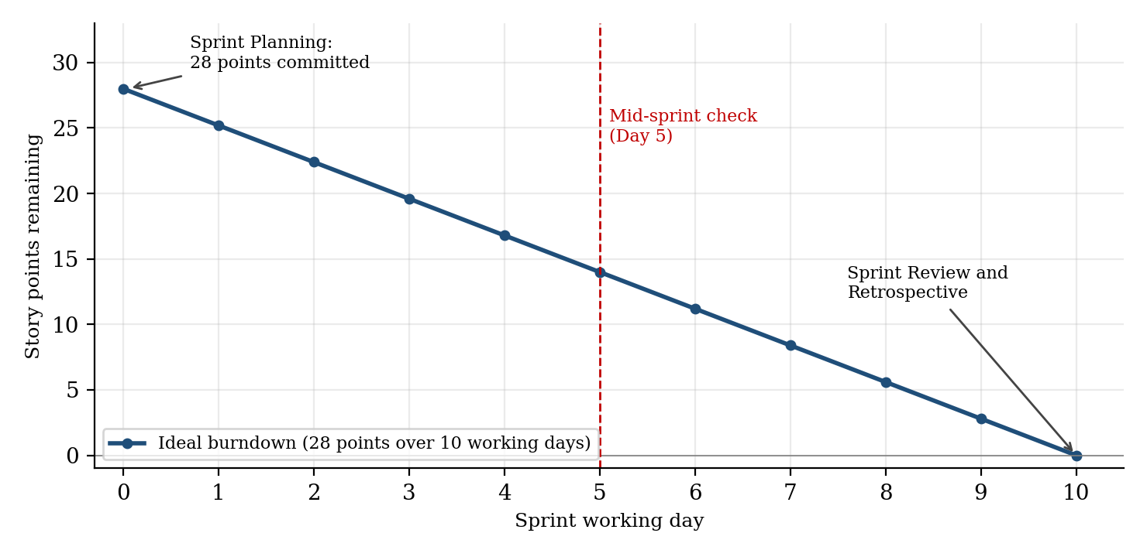
Figure 7.1: Sprint 1 ideal burndown (28 story points over 10 working days)
The chart shows the ideal line. During the sprint the remaining points are updated each day and compared against it.
7.5 Sprint Risks and Mitigation
Risk | Possible Impact | Mitigation
Weak authentication design | Security gaps that are expensive to fix later | Use a proven hashing library, add a dedicated security review task, test lockout rules.
Database schema changes later | Rework in all modules | Use migration scripts and get the ER diagram approved by the Product Owner this sprint.
Team unfamiliar with the tools | Slow start in the first days | Pair programming and a short set-up session on Day 1.
Invite delivery by e-mail or SMS is unclear | Story US03 may grow | Only the invite code and a notification stub are in scope; real delivery is planned with alerts in Sprint 3.

7.6 Summary
This plan turns the vision of the Smart Grocery Consumption and Reorder Management System into 26 user stories and one technical enabler in ten epics, ordered by dependency, value and need. Sprint 1 takes the first eight items (28 points, 231 planned hours) and delivers the secure foundation on which purchase tracking, reorder suggestions and prediction will be built in the following sprints.

Rubrics for Calculation
Criteria | Excellent (5 Marks) | Good (3 Marks) | Satisfactory (2 Marks) | Needs Improvement (1 Mark)
Project Vision & Stakeholder Identification (30%) | Project vision is clear, comprehensive, and aligned with the problem statement. All relevant stakeholders and their roles are correctly identified. | Vision is clear with minor omissions. Most stakeholders are correctly identified. | Vision is partially defined. Some stakeholders are missing or incorrectly identified. | Vision is unclear or incomplete. Stakeholders are poorly identified or missing.
Epics & User Stories (25%) | Epics are well-defined and user stories are complete, follow Agile format, and fully capture functional requirements. | Epics and user stories are mostly complete with minor formatting or requirement issues. | User stories are partially complete with limited Agile structure. | User stories are incomplete, unclear, or do not follow Agile practices.
Acceptance Criteria (20%) | Acceptance criteria are specific, measurable, testable, and aligned with all user stories. | Acceptance criteria are mostly clear and testable with minor gaps. | Acceptance criteria are partially defined and lack clarity or completeness. | Acceptance criteria are missing or not aligned with user stories.
Product Backlog Prioritization & Sprint Planning (15%) | Product backlog is logically prioritized, sprint backlog is realistic, and task breakdown is complete. | Backlog prioritization and sprint planning are mostly appropriate with minor issues. | Prioritization or sprint planning is partially complete with limited justification. | Backlog prioritization and sprint planning are poorly organized or incomplete.
Story Point Estimation, Sprint Goal & Presentation (10%) | Story point estimation is well justified, sprint goal is clear, deliverables are realistic, and presentation is professional and well organized. | Estimation and sprint goal are mostly appropriate with minor inconsistencies. Presentation is clear. | Estimation or sprint goal lacks justification. Presentation is adequate but incomplete. | Estimation is unrealistic or missing. Sprint goal, deliverables, and presentation are unclear or incomplete.

Criteria | Mark
Project Vision & Stakeholder Identification (30%) | /5
Epics & User Stories (25%) | /5
Acceptance Criteria (20%) | /5
Product Backlog Prioritization & Sprint Planning (15%) | /5
Story Point Estimation, Sprint Goal & Presentation (10%) | /5
TOTAL | /25

